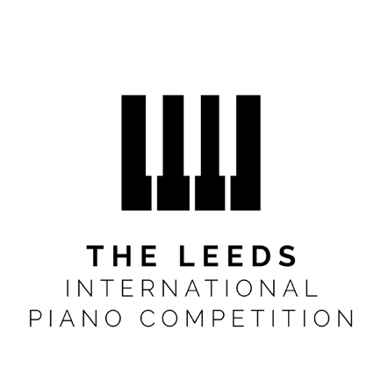

The Leeds International Piano Competition is one of the world’s foremost music competitions.
Since the first edition in 1963, 'The Leeds' has attracted the world’s finest young pianists and prize-winners include the Competition’s Patron Murray Perahia KBE, Radu Lupu, Mitsuko Uchida, András Schiff, Lars Vogt, Anna Tsybuleva, Federico Colli and Eric Lu.
The founders were three friends - Dame Fanny Waterman, Marion Thorpe Countess of Harewood and Rosalyn Lyons - who attracted young musicians to Leeds by the opportunities offered by an outstanding prize package, the challenge of demanding repertoire, a stellar jury, and the very warmest welcome from the people of Yorkshire.
In bold defiance of the pandemic, the 2021 International First Round reached 17 venues around the globe and The Leeds was the first major European competition to bring its live audiences back. Online, viewers around the world experienced The Competition in HD sound and video through medici.tv, BBC Four, BBC iPlayer, BBC Radio 3, amadeus.tv, mezzo.tv and Classic FM, attracting over 4.7 million views and listens across more than 140 countries during our 2021 Edition.

Helping our artists to develop is at the heart of what the Competition stands for. We seek not only to discover the finest young pianists, but to nurture and equip them for the swiftly changing world we are living in. Competitor + is a unique programme that provides career-enhancing opportunities and support packages for all our Competitors, and our Tabor Young Ambassadors programme supports the next generation of young competitors prepare for their competition journey.
We offer a prize package that is truly transformative, including worldwide management with Askonas Holt, a debut recording with Warner Classics, recitals at Wigmore Hall and the Southbank in London, tours of Europe and East Asia in association with Steinway & Sons, broadcast opportunities with the BBC and an extensive package of national and international engagements with a range of promoters and orchestras, including the Royal Liverpool Philharmonic Orchestra.
Perhaps most importantly, we are passionate about the role of the piano to inspire diverse communities and bring people together, both locally and around the world. We offer unique opportunities for Competitors and Prize-winners to connect with audiences beyond the concert hall and develop year-round programmes with our community and educational partners, including our famed Leeds Piano Trail.

(380 Words)

